**IPL 2023 Cricket analysis Report:**

The IPL 2023 Cricket tournament involved a total of 74 matches and the teams involved in the tournament were,

* Mumbai Indians
* Chennai Super Kings
* Delhi Capitals
* Royal Challengers Bangalore
* Gujarat Titans
* Lucknow Super Giants
* Punjab Kings
* Rajasthan Royals
* Sunrisers Hyderabad
* Kolkata Knight Riders

Chennai Super kings were crowned champions of the tournament.

The main idea of this project was to identify the team of the tournament based on the different parameters.

The players in each category like Openers, Middle order, Finishers, All-rounders, Fast bowlers are selected based on certain parameters.

The parameters are,

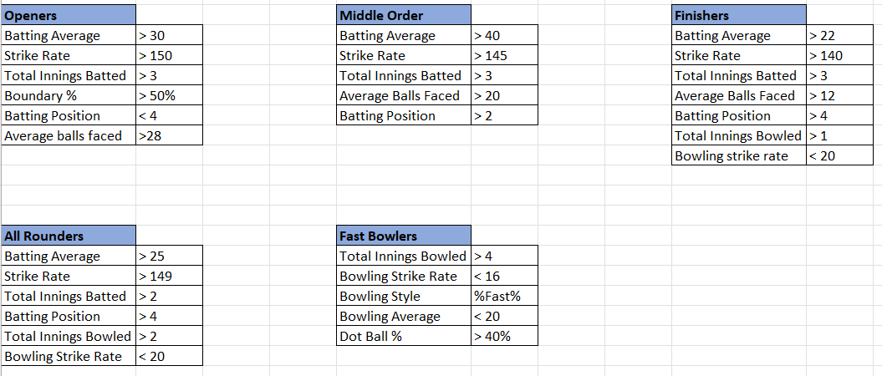

**Openers:**

* Shubman Gill with a total tally of **890 runs** has an average of **59.33** with boundary percentage of **60.45%.**
* Faf du Plessis has an average of **56.15** with boundary percentage of **62.47%.**

These two players are shortlisted for the openers category selection.

**Middle Order:**

* Suryakumar Yadav has an average of **43.21** with boundary percentage of **70.74%** along with an astonishing strike rate of more than **180.**
* Heinrich Klassen has an average of **49.78** with boundary percentage of **62.05%** but has a very good strike rate of **177.08**. Also, he is a wicket-keeper batsman.
* Rinku Singh has an extraordinary average of **59.28** with boundary percentage of **62.87%** but has a hit a total of **29** sixes in the tournament.

These three players are shortlisted for the openers category selection.

**Finishers:**

* Rahul Tewatia has a batting average of 21.75with boundary percentage of **62.07%** along with a good strike rate of more than **150** and has an economy of **6.92.**
* Ravindra Jadeja has an average of **23.75** with a good strike rate of **140+**. Also, he has taken 20 wickets in the tournament.

These two players are shortlisted for the openers category selection.

**All-rounders:**

* Rashid Khan has a very good strike rate of more than **215** with boundary percentage of **80+** and has an economy of **8.24.** He has also taken 27 wickets in total.
* Marcus Stoinis has a batting average of **31.38** with a good strike rate of **150+**. Also, he has scored more than **400** runs in the tournament. He has a good bowling strike rate of **13.**

These two players are shortlisted for the openers category selection.

**Fast Bowlers:**

* Mohammed Siraj has taken a total of **19** wickets with an economy of **7.5** .He has the dot ball% of **54%** and can take wickets in every 16 deliveries(Bowling strike rate).
* Mohammed Shami has a good economy of **8**.**03** an over and has taken **28** wickets in the tournament with a good bowling strike rate of **13.93.**

These two players are shortlisted for the openers category selection.

So, the final team of the tournament is,

1. Shubman Gill
2. Faf du Plessis(c ) ✈
3. Suryakumar Yadav
4. Heinrich Klassen(wk) ✈
5. Rinku Singh
6. Rahul Tewatia
7. Ravindra Jadeja
8. Rashid Khan ✈
9. Marcus Stoinis ✈
10. Mohammed Siraj
11. Mohammed Shami

( * ✈ denotes foreign player)

This team is also following the general selection of an IPL team which cannot exceed more than 4 foreign players. Faf du Plessis can captain this team while Klassen can do the wicket-keeping duties for this team.

**Top 5 run getters of the tournament:**

Shubman gill tops the run getters list with a total run tally of 890 runs. Second in the list is Faf du Plessis followed by Devon Conway, Virat Kohli and Yashasvi Jaiswal.

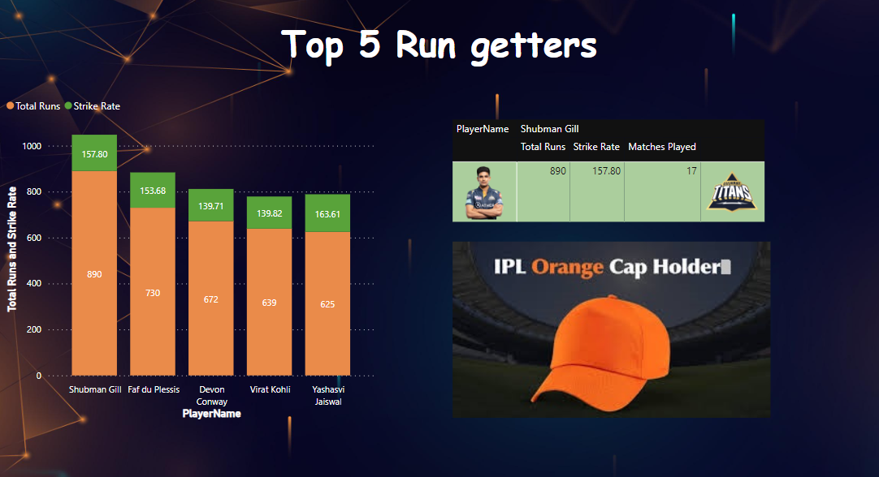

**Top 5 wicket takers of the tournament:**

Mohammed Shami tops this list with a total wicket tally of 28 wickets. Second in the list is Mohit Sharma and Rashid Khan with 27 wickets each. Third in the list is Piyush Chawla followed by Tushar Deshpande and Yuzvendra Chahal.

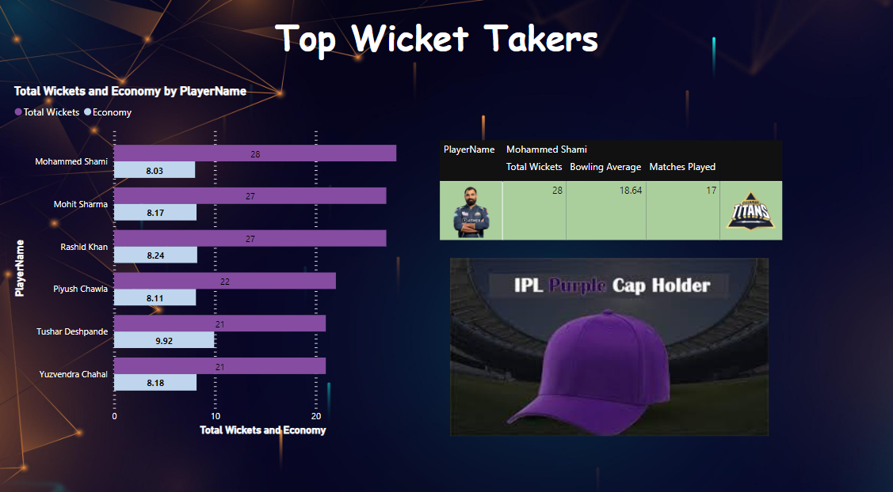

**IPL 2023 in numbers:**

The tournament has seen a total **1124** sixes and **2174** fours been hit. **857** wickets were taken, **16** maiden overs were bowled, **6101** dot balls were bowled and **141** fifties & **12** hundreds were scored in the tournament.

Based on the Boundary% scored, **Mumbai Indians** looks to be the aggressive team with a boundary % of **67.35%** and they have the more number of sixes hit by a team with the count of **140** sixes overall in the tournament. Bowling wise, **Gujarat Titans** looks to be disciplined bowling team by topping the wickets taken by a team and Dotball% bowled by a team lists. They have **38.33%** of Dotball % and have taken a total of **118** wickets. In Batting wise, they have also scored the most runs by a team(**2906** runs). **Delhi Capitals** is considered to be a low performing team in terms of runs scored because they find themselves in the bottom of the table in both the sixes hit by a team and Boundary% teamwise lists and also, they have the least total runs scored by a team(**2073** runs).